**Experiment instructions**

In this experiment, you will listen to brief (~5 – 20 seconds long) sequences of auditory tones. The pitch of these tones can take on many values from high to low, and will vary throughout the tone sequence.

**Trend strength**

Crucially, different tone sequences will exhibit different **trends** or **tendencies** in how the pitches of the tones change over time. When we say the pitch of the tones follows a trend, we mean that

* the pitch tends to follow long-term trends or overall patterns over time, such as gradually rising or falling
* the tone pitches you have heard so far gives you some information about what tone pitch is likely to come next

In this experiment, tone sequences follow three levels of **trend strength**: low, medium, and high. The stronger the trend strength, the more prominent and consistent is the long-term trend of changes in pitch over time. For example, although you will not hear such sequences in this experiment, zero trend strength would correspond to random changes in pitch with no pattern at all, and very high trend strength would correspond to a continuously increasing or decreasing pitch sequence.

Even for the sequences that have the strongest trends in this experiment, the pitch of an upcoming tone cannot be predicted perfectly. However, in sequences with stronger trends, the tones you’ve heard so far are more informative about the **likely** pitch of the upcoming tone.

Intuitively, you can think of “trend strength” as a measure of **tendency** in the sequence. Sequences with higher trend strength have a higher tendency for longer portions of the sequence to exhibit similar overall levels of pitch or changes in pitch over time. It is precisely these longer-term tendencies for trends to occur that make past tones in the sequence informative about upcoming tones.

**Visual examples of trend strength**

To make this more concrete, let’s take a look at some examples of sequences that have different levels of trend strength. You can think of the x-axis as representing time and the y-axis as representing pitch (higher values = higher-pitched tones).

Turn to the next page to see these examples.

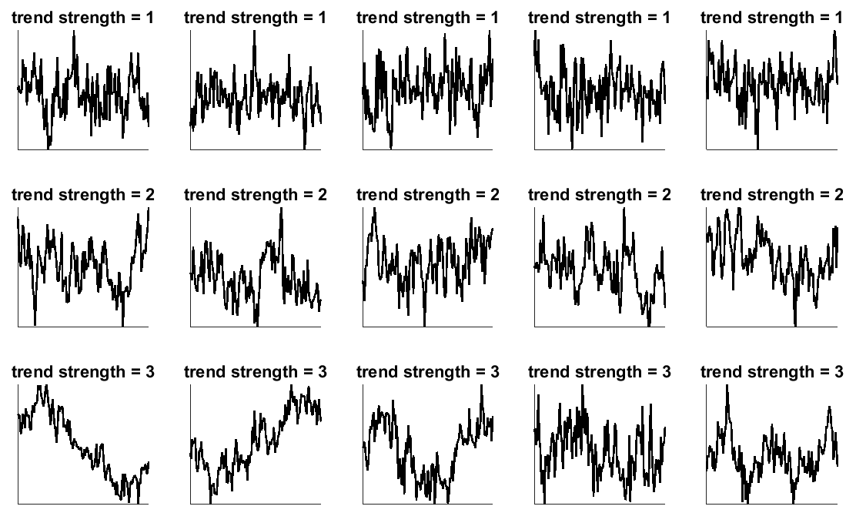

Notice the following about these examples:

* Trend strength can take different values, ranging from weak (top row, trend strength = 1) to strong (bottom row, trend strength = 3).
* Trends don’t have to be perfectly predictable patterns—they are just tendencies for large parts of the sequence to take on similar values, or to drift in similar directions.

**Experimental task**

After listening to each sequence of tones, you will be asked to make two judgments about the sequence.

First question

**How likely was the pitch of the final tone?**

The very last tone in the sequence is selected in a different way than the others. Sometimes the final tone will ‘fit in well’ with the sequence you have heard so far. Other times, it may ‘break the trend’ and not fit in well at all.

You must first tell us how well the final tone fit in with the preceding sequence. You will do this by rating *how likely* it is that a tone sequence like the one you just heard would culminate with the final tone that was actually played.

The rating is done on a scale of 1 – 5, where

1 = the final tone was very unlikely; I was not expecting a tone like that to be played at all; it did not fit in at all with the preceding sequence

5 = the final tone was very likely; it was close to what I was expecting it to be; it fit in well with the preceding sequence

IMPORTANT! Try to use all 5 options of the rating scale. That is, do not limit yourself to only ever using 2 or 3 responses on the 5-point scale. You should use all 5 options at least some of the time, while still faithfully reporting your judgment about the final tone likelihood.

Second question

**What was the trend strength of the sequence?**

Now you will have to make a judgment about the sequence of tones as a whole (excluding the final tone). What was the trend strength of this sequence?

**Crucially, you must judge the trend strength of the whole series *except for* the very last tone that is played. As explained above, the final tone of the sequence is selected differently from the others and is not a reflection of the underlying trends characterizing the sequence of tones that preceded it.**

The rating of trend strength is done on a scale of 1 – 3, where

1 = weak trend; there was a slight overall tendency in how the pitch changed over time, but also a lot of randomness

2 = medium trend

3 = strong trend; large portions of the sequence exhibited similar pitches or tendencies to change in pitch

The values of trend strength from 1 to 3 that you will use to categorize each auditory sequence correspond to the values of trend strength from 1 to 3 shown in the visual examples above. You may want to study these visual examples again to get an idea of what is meant by each level of trend strength.

Each tone sequence you will hear has a ‘true’ trend strength ranging from 1 to 3, where again these values for trend strength are illustrated in the examples above. Thus, your rating for the trend strength of a given sequence can be correct or incorrect. You will be informed whether your trend strength rating was correct or incorrect at the end of each trial.

Response times

For each of the two questions, you will have up to 5 seconds to answer. If you don’t answer in time, a ‘Too slow!’ message will appear on the screen and the next trial will begin.

We can’t use trials where you don’t answer both questions within the time limit, so please be mindful of entering both responses within a reasonable amount of time.

If you are completely unsure of what to respond, it is OK to guess. It is much better to guess than to fail to enter any response at all.

If you do have to make a guess, try to make sure your guess is chosen randomly. That is, don’t employ a rigid strategy for guessing, such as “if I’m not sure what the trend strength was, I will always press my index finger.” Instead, your strategy for guessing should be more like “if I’m not sure what the trend strength was, I will just enter my best guess, and I have no best guess at all, I will just push a random button.”

Performance feedback, practice, and questions

After you have entered your two responses, you will see a message on the screen letting you know how close your trend strength rating was to the true trend strength. This will help you get a grasp on how to answer the trend strength question.

You will also get a chance to practice before beginning the main experiment. This will give you a feel for how to answer the two questions for each tone sequence, and how to enter your responses using the button boxes.

If anything is unclear, please do not hesitate to ask the experimenter. This may seem like a lot to digest, but you will get the hang of things quickly once we start doing some practice trials.

In the MEG scanner

If you will be performing this task in the MEG scanner, you will alternate between break periods where you can rest, and active periods where you are doing the task and the scanner is recording. During the active periods, it is important to be mindful of the following:

* Please move as little as possible.
* Please do not close your eyes. (It is OK to blink if you need to, but try to minimize blinks as well.)

In the break periods it is OK to close your eyes, but you should still try to minimize movement if possible.